**Step by Step Guide to Create Installment Plan**

**Step 1: Adding Project and Plot Information**

* Rate per Marla * Plot Size (In Marla) = Plot Price
* Remaining (Dynamically Calculates and Shows the amount Remaining from installments allocation)

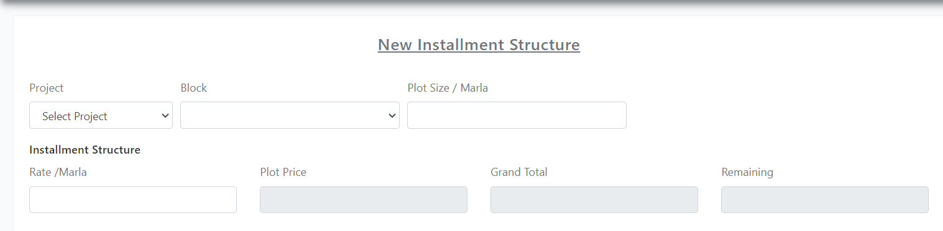

**Step 2: Adding Installments of Different Types**

Following are Installment Types that can be included in the Plan

1. **other charges**

* To add any single occurring installment That is not included in below given types can be added selecting Other charges installment type.
* Calculation Types Can be selected Fixed Charges or percentage for Single Occurring Installments which include Advance, Confirmation, Possession, Development Charges.

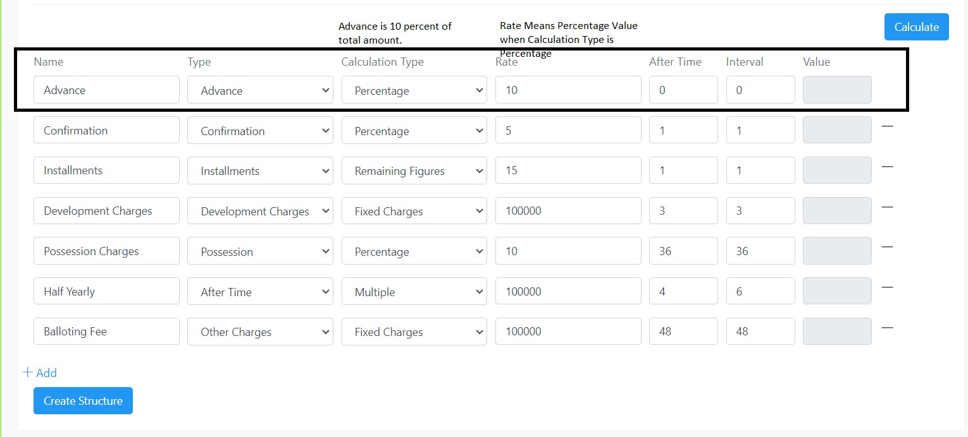

1. **Installments**
2. **Development Charges**
3. **Advance**
4. **Possession**
5. **After Time(Half Yearly, Annual Quarterly etc.)**
6. **Confirmation**

* For All Installment Types Other than **“Installments”** and **“After Time”** **Calculation Type** will be **Percentage** or **Fixed Charges**.
* Column **“Rate”** Defines Percentage number for example 10%, 15%.
* Column **“After Time”** (in months) means after how many months this installment is due.
* Column **“Interval”** Means after every (how many months), You have to Give same value In Interval Column and After Time Column Except for **“After Time”** Installment Type.

**For Installment Type “After Time”**

* Calculation Type will be **“Multiple”.**
* Column **“Rate”** Defines Amount for each Installment of that type (Type can Be any Like Half Yearly. Quarterly, Annual etc.).
* **“After Time”** Column means how many installments of that type (For example 50000 in **Rate** Column and 4 in **After Time** column means, 4 installments of 50000 each).
* Column **“Interval”** defines when they will be due (Enter 6 in interval column for Half Yearly and 12 for Annual, 3 for Quarterly in Interval Column and so on).

**For Installment Type “Installments”**

* Select Type **“Installments”.**
* Calculation Type will be **“Remaining Figures”** (It will get amount that is left from all other installments amount and will make monthly installments, or after how many months you choose like 2, 5 etc.)
* **“Rate”** Column means How many installments like 48, 36 , or 12 etc.
* In **“After Time”** Column you’ll give 1 if you want to create monthly installment.
* It will Divide Remaining Amount with Rate Column (For Example Remaining Amount is 120000, Rate is 12, After time is 1, It will Create 12 monthly installments 10000 each).

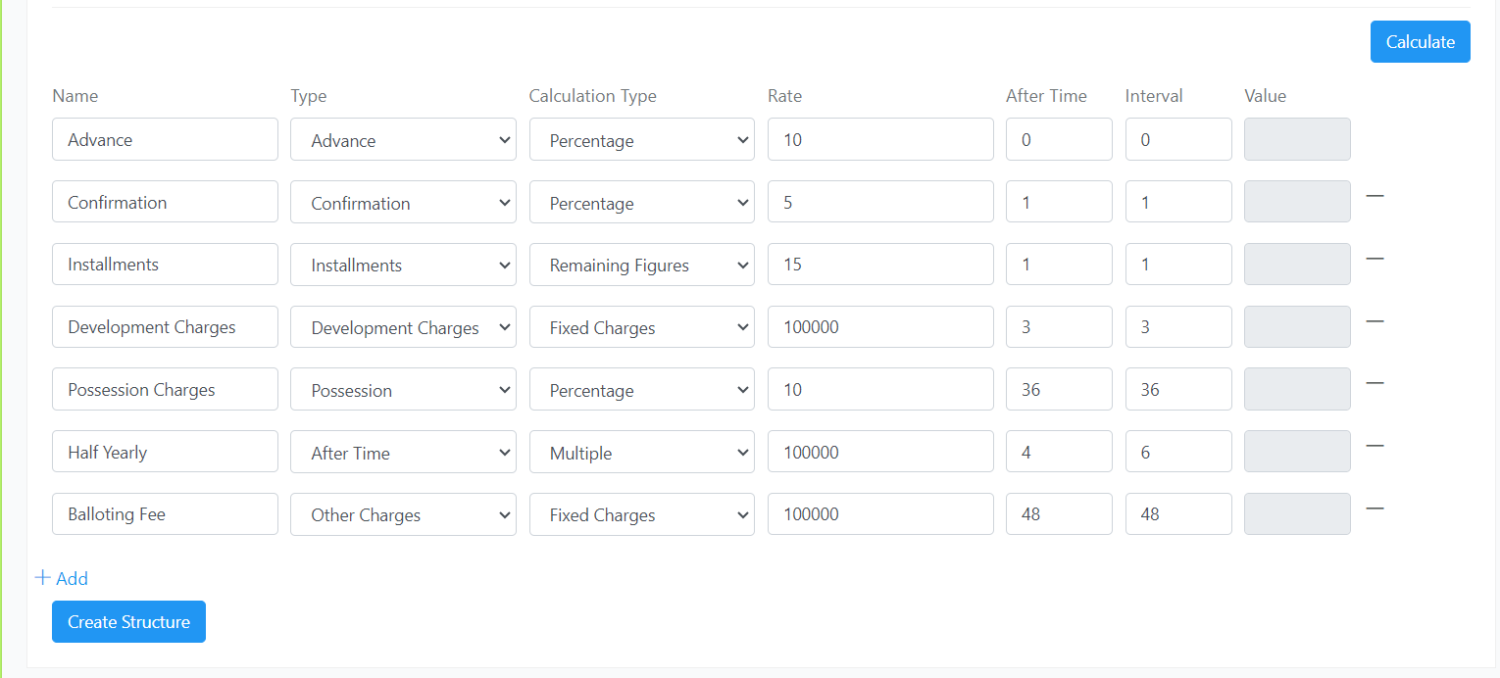

**Complete Picture**

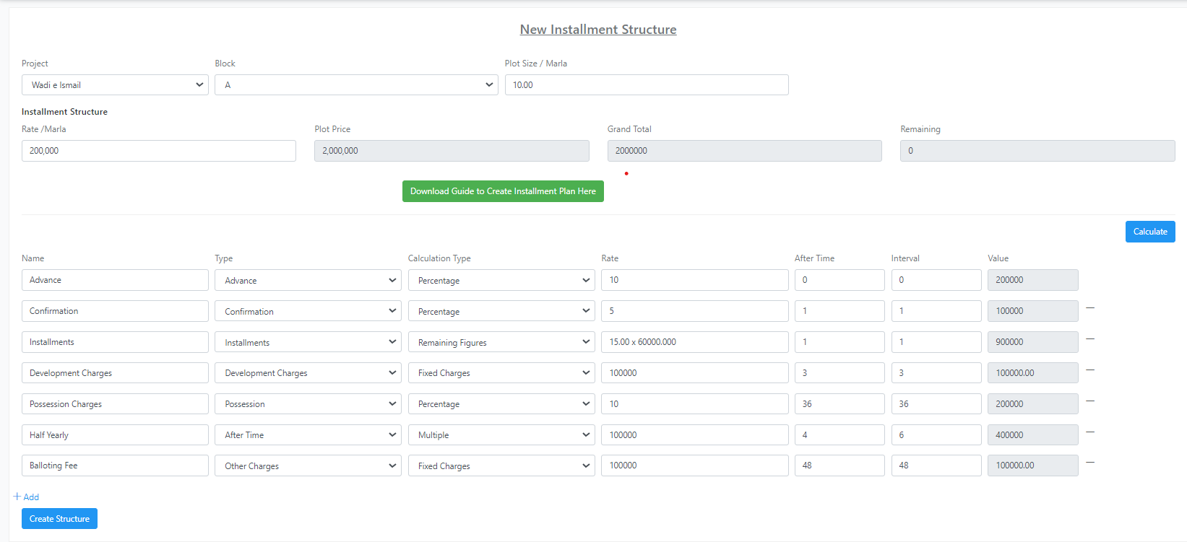

In case of any queries, kindly contact SA Systems team.